Extended Mendelian Genetics
7.1 Chromosomes and Phenotype

Objectives:

Key Concept:

Vocabulary

Autosomal Gene Traits
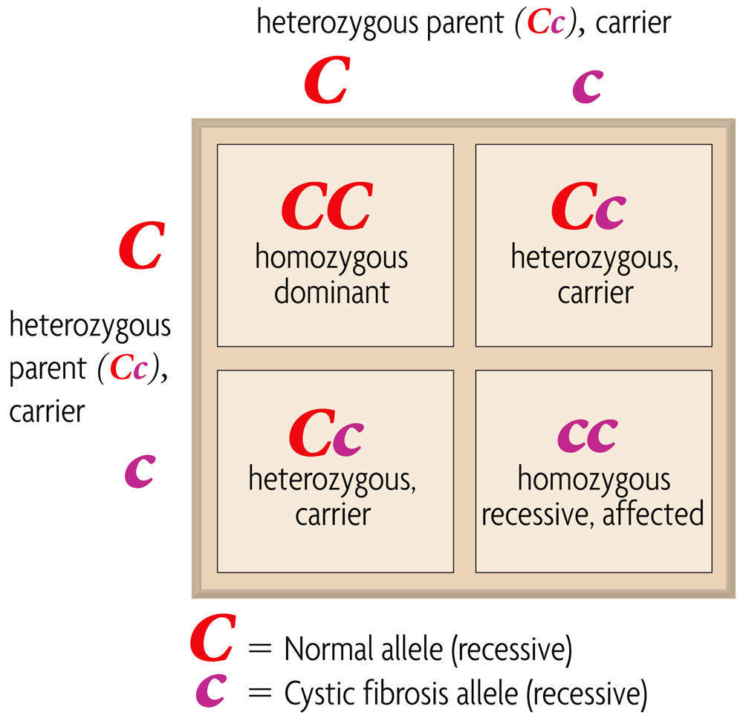
(dominant)

Sex-linked Traits

Notes

The __________________________, on which genes are located, can affect the ________________________ ___________ ______________________.

- Carrier
- Sex-linked gene
- X chromosome inactivation

_____________ copies of each ____________________ gene affect _________________________.

- Mendel studied _____________________ gene traits, like ____________ __________________
- Other examples of autosomal gene traits:

- Mendel’s ________________ of ________________ apply to _______________ genetic disorders
  - A __________________________ for a recessive disorder is a ____________________
  - Disorders caused by ________________ alleles are uncommon

Why do you think Disorders caused by dominant alleles are uncommon?

Answer on your EXIT TICKET

Males and females can differ in ____________________ _____________________.
- Genes on _________ _____________________ are called _________________________ genes
  - Y chromosome gene in mammals are responsible for _______ characteristics
Sex-linked Traits continued
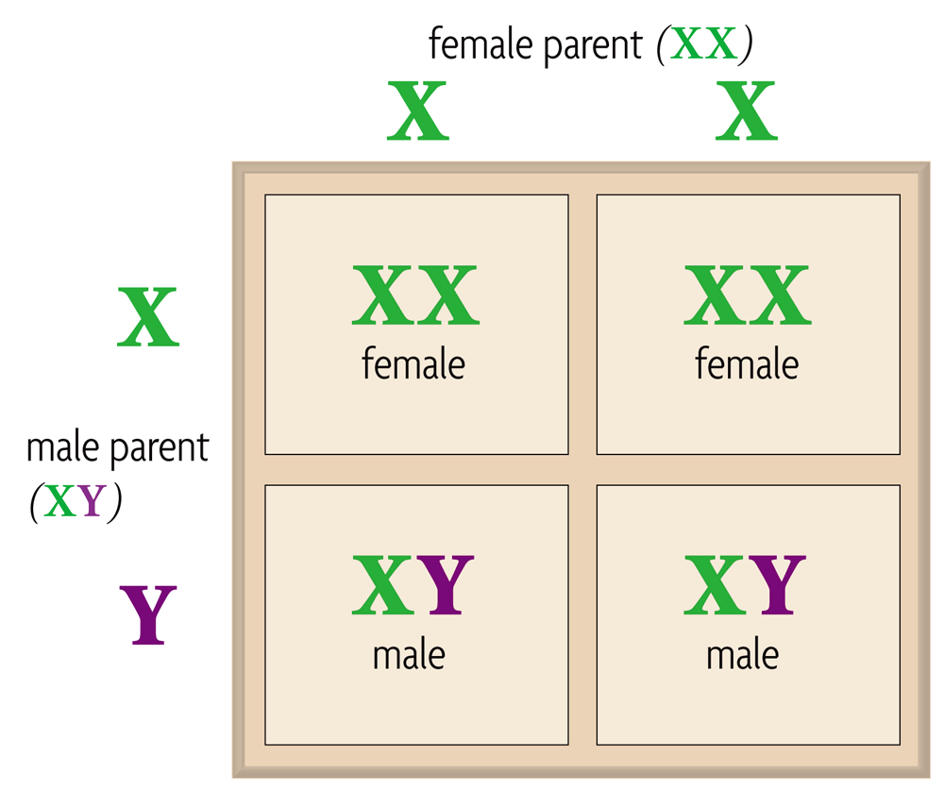

Autosomal vs Sex-linked Disorders

Autosomal Sex-Linked (X-linked)

  - X chromosomes genes in mammals affect _______________ traits
- Male mammals have an ___________ genotype
  - __________ of a male’s sex-linked genes are ________________________
  - Males have ________ ______________ copies of sex-linked genes.
- Female mammals have an ________ genotype
  - Expression of sex-linked genes is similar to ________________ genes in females
  - X chromosome __________________ randomly “______________ ________” one X chromosomes.
Why do you think male Calico cats are rarely found?

Answer on your EXIT TICKET

